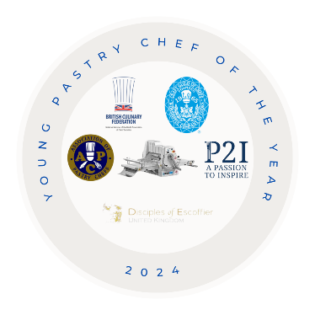

YOUNG PASTRY CHEF OF THE YEAR 2024
The competition is open to any pastry chef aged 23 years and under on the 1st March 2024. The Candidate should be actively working in a hotel or restaurant kitchen, banqueting, college student or within any corporate/event catering environment.

All entries to Murray Chapman before 26th March and the finalists will be notified on the 24th April - any queries contact murray@firstcontactuk.com a panel of industry experts will select the 8 finalists.

Date of the final - Tuesday 18th June – University College Birmingham

NAME ___________________________________________________________________________

DATE OF BIRTH ___________________________________________________________________

ESTABLISHMENT __________________________________________________________________

________________________________________________________________________________

JACKET SIZE ________________ (UK inches / EURO CMS)
(please circle as appropriate)

I confirm that the recipes I am submitting are my own work.

Signed: __________________________________________________________________________

I, _______________________________________, the undersigned Head Chef/Lecturer fully support my chef’s entry.

Signed: __________________________________________________________________________

Proprietor/Head Chef / Department signature: (if different from the above)

Signed: __________________________________________________________________________

By signing this form, you agree to allow the applicant to participate in this competition and any promotional activities associated with receiving any awards.
Send your completed entry form together with dish names, recipes, methods, timings and costings

