**Craft Guild of Chefs**

**Education and Training Summit 2025**

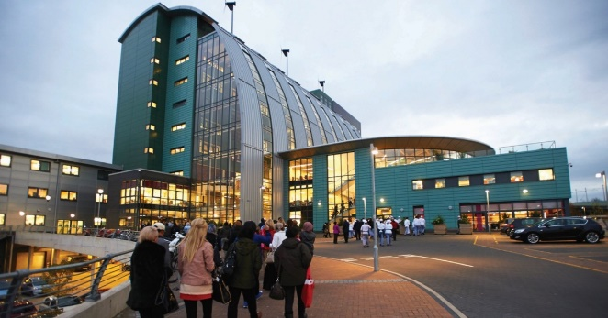

**Thursday 9th – Friday 10th January 2025**

The 2025 Craft Guild of Chefs Education and Training Summit will take place at The Sheffield College on Thursday 9th and Friday 10th January.

We offer up the following packages:

**Package A - £180.00 – (£150 ex VAT)**

This package includes 1 nights’ accommodation on Thursday 9 January at the Jonas Hotel at the University of Sheffield. Evening dinner at The Silver Plate, The Sheffield College. Plus, the business programme with refreshments and lunch at The Sheffield College on Friday 10 January. Transport between the Jonas Hotel and Sheffield College will be provided for delegates.

**Package B - £102.00 – (£85 ex VAT)**

This package includes Evening Dinner at The Silver Plate, The Sheffield College on Thursday 9 January. Plus, the business programme with refreshments and lunch at The Sheffield College on Friday 10 January.

**Package C - £72.00 – (£60 ex VAT)**

This package includes the business programme with refreshments and lunch at The Sheffield College on Friday 10 January.

**All prices inc VAT and per person**

**Education and Training Summit 2025 - Booking Form**

**Name:**

|  |
| --- |
|  |

**College/Company Name:**

|  |
| --- |
|  |

**Email address:**

|  |
| --- |
|  |

**Phone number:**

|  |
| --- |
|  |

**Package Option:**

|  |  |
| --- | --- |
| Package A |  |
| Package B |  |
| Package C |  |

**Total cost:……………………………………………………….**

|  |  |
| --- | --- |
| **Delegates Name** | **Dietary Requirements** |
|  |  |
|  |  |
|  |  |
|  |  |
|  |  |
|  |  |
|  |  |