**Craft Guild of Chefs**

**Education and Training Summit 2025**

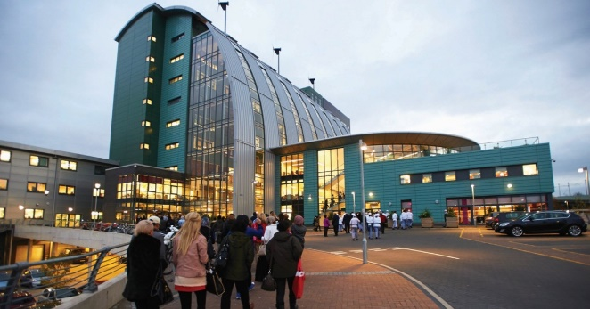

**Thursday 9th – Friday 10th January 2025**

**Programme**

**The Silver Plate Restaurant , Granville Rd. , Sheffield S2 2RL**

**Aims**

To outline the progress of the Craft Guild of Chefs accreditation programme.

To share knowledge and experience from current accredited colleges and training organisations.

To identify opportunities for students to work with industry.

To describe the arrangements for the Accredited College of the Year Award 2025.

**Who should attend ?**

The summit is open to all colleges, universities , training organisations , business partners and industry. The Craft Guild of Chefs also welcomes those interested in accreditation who have yet to make a decision.

**Thursday 9 January 2025**

3.00pm Residential delegates check into Jonas Hotel

5.30pm Transport leaves for Sheffield College

6.00pm Drinks reception followed by Dinner at The Silver Plate Restaurant at The Sheffield College.

Our Guest Speaker at dinner will be **Chris Galvin.**

**Friday 10 January 2025**  
**9.15am Welcome and Introduction**

Mark Reynolds, Chair of Craft Guild of Chefs

Journey so far and milestone achievements

**9.30am Why Accreditation ?**  
Presented by David McKown  
An outline of benefits and the process to becoming an accredited centre.

**9.45am** **Training Restaurants the New Challenge**

Key insights into the operation of the Silver Plate Restaurant at The Sheffield College presented by Andrew Gabbitas

Key insights into the operation of The Brasserie and The Escoffier Room at Westminster Kingsway College presented by Miranda Quantrill

**10.15am Peter Avis, Hilton Park Lane**

**A Spotlight on Food and Beverage Service**

Peter is an award-winning General Manager, with over 25 years of international experience in the hospitality sector.

**10.45am The Exclusive Academy**

How the Exclusive Academy works and their relationship with colleges.

Presented by Andy McKenzie, Executive Chef, Exclusive Chefs Academy.

**11.15am : Break**

**11.45am : Update from City & Guilds**

Jason Benn , City and Guilds , Industry Manager for Hospitality & Catering , Travel and Tourism .

**12.05pm: Looking to the Future of Hospitality Education**

How the UK may consider the development of people for the Hospitality Industry.

This session will include **global insights** and competitions.

Professor David Foskett and Neil Rippington.

**12.30pm Our Panel “Rebuilding Hospitality Colleges”**

Featuring :-

Angela Maher, Chief Executive, The Savoy Educational Trust

Vita Whittaker, CEO , Whitco

Steve Hobbs , Director , Grande Cuisine

**1pm Buffet Lunch**

**1.45pm : Changes to the Craft Guild of Chefs College Accreditation Programme**

This session will include an overview of the assessment methodology for the five-year college accreditation assessment. In addition, the arrangements for the Accredited College Training Restaurant of the year will be revealed.

**2.30pm Event Closes**

*Short 10 minute walk to Sheffield Railway Station for those travelling by train.*

**Venue for Summit :**

**The Silver Plate Restaurant**

**The Sheffield College**

**Granville Rd**

**Sheffield**

**S2 2RL**

**Accommodation :-**

**Jonas Hotel**

**University of Sheffield**

**Endcliffe Vale Rd.**

**Sheffield**

**S10 3ER**