Craft Guild of Chefs – Golf Day 2022

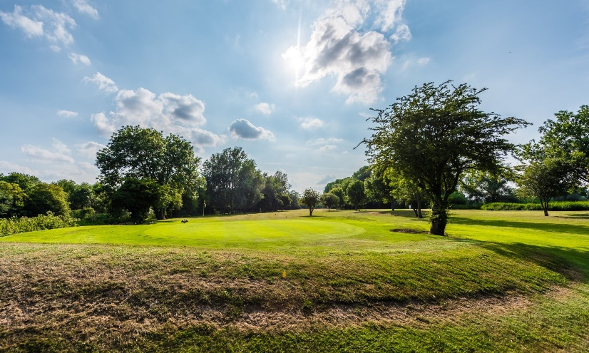

Wyboston Lakes Resort
Thursday 12th May 2022

The 2022 Craft Guild of Chefs Golf Day will take place at the Wyboston Lakes Resport on Thursday 12th May 2022. The outstanding course will host this excellent event, and we offer up the following packages:

Option One - £210.00
Single accommodation superior room and breakfast
Bacon roll/Tea/Coffee on arrival
18 holes of Golf
3 course dinner with wine

Option Two - £165.00
Shared accommodation (twin) and breakfast
Bacon roll/Tea/Coffee on arrival
18 holes of Golf
3 course dinner with wine

Option Three - £85.00
Bacon roll/Tea/Coffee on arrival
18 holes of Golf
3 course dinner with wine

All prices inc VAT

Golf Day 2022 - Booking Form

Name:

Company Name:

Email address:

Phone number:

Package Option:
Option One
Option Two
Option three

Total cost:……………………………………………………….

Players Name | Players Handicap

***Golf Buggys to be booked directly with Wyboston, these are very limited***

