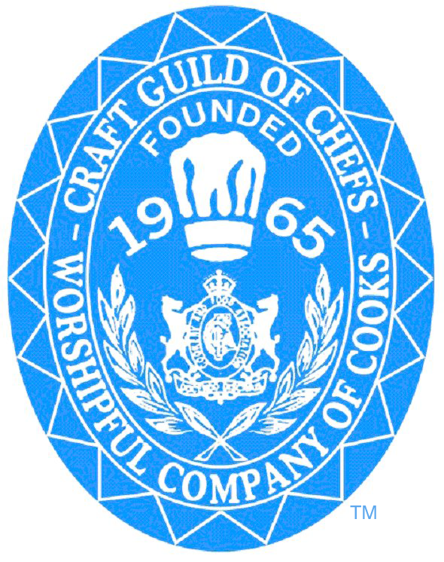

VOTING BALLOT

NOMINATIONS FOR THE NATIONAL COMMITTEE OF MANAGEMENT
NOMINATIONS DECLARED FOR ELECTION 2021 – 2022
ANNUAL GENERAL MEETING
11th April 2021
Via Zoom
Pre-recorded
Called in accordance with Rule 15, 16, and 17 of the Rule Book.
BY ORDER OF THE COMMITTEE OF MANAGEMENT.

- NATIONAL CHAIRMAN
- NATIONAL VICE CHAIRMAN
- YOUNG CHEF AMBASSADOR
- SOCIAL MEDIA CO-ORDINATOR
- EDUCATION & TRAINING
- WELLBEING AMBASSADOR
- CULINARY ACADEMY
- SOCIAL SECRETARY
- MEMBERSHIP AND BENEFITS

____________________________________________________________________
Elected Member of the
Committee of Management 2021-2022
National Chairman

The following ONE nomination has been received for ONE vacancy for a three year annually elected term as follows:

Mr. Matt Owens
Proposed: Mrs. Pauline Tucker
Seconded: Mr. David Mulcahy
____________________________________________________________________________________________
Elected Member of the
Committee of Management 2021-2022
National Vice Chairman

The following TWO nominations have been received for ONE vacancy for a three year annually elected term as follows:

Mr. Mark Reynolds
Proposed: Mr. Matt Owens
Seconded: Mr. David Mulcahy

Mr. Daniel Ayton
Proposed: Mrs. Maria Drury
Seconded: Mr. Craig Martin
_________________________________________________________________________________________

Elected Member of the
Committee of Management 2021-2022
Young Chef Ambassador

The following ONE nomination has been received for ONE vacancy for a one-year term as follows:

Ms. Amber Francis
Proposed: Mr. Matt Owens
Seconded: Mr. Mark Reynolds
_________________________________________________________________________________________
Elected Member of the
Committee of Management 2021-2022
Social Media Co-ordinator

The following ONE nomination has been received for ONE vacancy for a one-year term as follows:

Mrs. Alison Cullin-Woodcock
Proposed: Mr. David McKown MBE
Seconded: Mr. Matt Owens
__________________________________________________________________________________________
Elected Member of the
Committee of Management 2021-2022
Education and Training

The following TWO nominations has been received for ONE vacancy for a one-year term as follows:

Mr. David McKown MBE
Proposed: Mrs. Alison Cullin-Woodcock
Seconded: Mr. Matt Owens
____________________________________________________________________________________________
Elected Member of the
Committee of Management 2021-2022
Wellbeing Ambassador

There has been TWO nominations for this position but ONE vacancy for a one year annually elected term as follows:

Mr. Andrew Aston
Proposed: Mr. Matt Owens
Seconded: Mr. Mark Reynolds

Mr. Daniel Ayton
Proposed: Mrs. Maria Drury
Seconded: Mr. Craig Martin
___________________________________________________________________________________________
Elected Member of the
Committee of Management 2021-2022
Culinary Academy

The following ONE nomination has been received for ONE vacancy for a one-year term as follows:

Mr. Peter Joyner
Proposed: Mr. Matt Owens
Seconded: Mr. Mark Reynolds
_____________________________________________________________________________________________

Elected Member of the
Committee of Management 2021-2022
Social Secretary

The following TWO nominations have been received for ONE vacancy for a one-year term as follows:

Mr. Connor Godfrey
Proposed: Mr. Connor Godfrey
Seconded: Mr. Mark Reynolds

Ms. Jacky Moss
Proposed: Mr. Darren Creed
Seconded: Mr. Tony Baughan
__________________________________________________________________________________________
Elected Member of the
Committee of Management 2021-2022
Membership & Benefits

There has been ONE nomination for this position for ONE vacancy for a one-year term as follows:

Mr. Richard Hunt
Proposed: Mrs. Alison Cullin-Woodcock
Seconded: Mr. Matt Owens
___________________________________________________________________________________________

Requests to Stand for Sub Committee

Mr. Phil Dixon – Culinary Academy Mr. Ian Sneddon – Culinary Academy
Mr. Allan Hodnett – Culinary Academy Mr. Fergus Martin – Culinary Academy
Mr. Ian Jaundoo – Education & Training Mr. David Foskett – Education & Training
Mr. Alan Paton – Education & Training Mr. Lee Allsup – Education & Training
Mr. Ian Page – Young Chef Ambassador
_____________________________________________________________

Divisional Representatives are Elected within own Division

Current Division Chairs:

Mrs. Maria Drury – London Division Mr. David Chalk – Jersey Division
__________________________________________________________________________________

The following Committee of Management Positions are not open for Election as they are appointed:

Trustees

Mrs. Pauline Tucker – Senior Trustee Mr. Stephen Scuffell – Trustee Mr. Duncan Holloway – Trustee

Vice Presidents and Vice President Council

Mr. Stephen Scuffell – Chairman of the Vice Presidents Council Mr. Steve Munkley
Mr. John Retallick Mr. Don Irwin
Mrs. Pauline Tucker Mr. Nick Vadis
Mr. Giovanni Fontebasso Mr. Geoff Acott MBE
Mr. David Mulcahy Mr. Andrew Green
Mr. Duncan Holloway Mr. Christopher Basten
Mr. Roy Perrett
Chief Executive

Mr. Andrew Green

Word: Voting Ballot 2021

